KOHLER MIT Project
20.09.2026
─
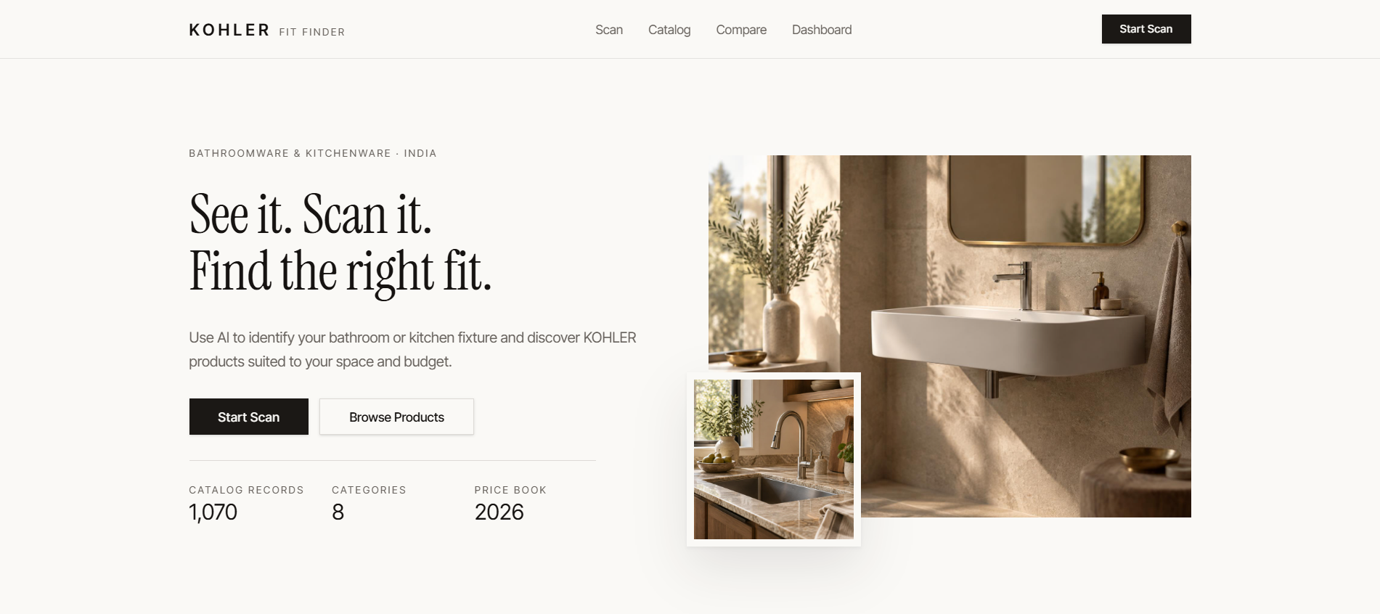
Kavya Rane
1262241582
Third Year BTech Computer Science and Engineering (AI/DS)
Case study 1: KOHLER AI Bathroom Designer & Planner

Overview
KOHLER Fit Finder uses Google Gemini's multimodal vision capabilities to analyze uploaded images of bathroom and kitchen fixtures. The AI identifies the fixture category and possible visible issues and returns structured information that is passed to the application's recommendation workflow.
The product recommendation itself is handled by application logic using the KOHLER price-book catalog and user constraints such as budget, space dimensions, and finish preference. This separates visual interpretation from deterministic product matching.

Supported AI concepts

Fixture classes
- Bathroom faucet
- Washbasin
- Toilet
- Shower
- Bathtub
- Kitchen faucet
- Kitchen sink

Issue classes
- Leakage
- Visible damage
- Crack
- Corrosion
- Broken component
- Replacement needed
- No visible issue

Image Analysis Prompt
Purpose: identify the visible fixture and possible visible issues while restricting the response to categories understood by the application
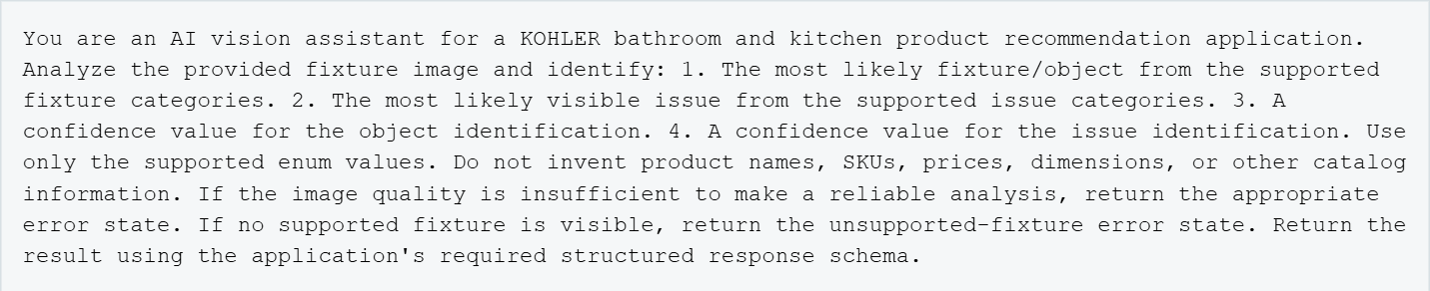
- Constrain outputs to application supported categories.
- Separate visual identification from product recommendation.
- Do not ask the model to invent catalog facts.
- Handles poor-quality and unsupported images explicitly.
- Return structured data for application validation.
SYSTEM INSTRUCTIONS
You are assisting with bathroom and kitchen fixture identification. Follow these rules:
1. Only select from the supported fixture categories.
2. Only select from the supported issue categories.
3. Do not invent product or catalog information.
4. Base the analysis only on the provided image.
5. Provide confidence values for both fixture and issue detection.
6. Handle poor-quality images explicitly.
7. Handle unsupported fixtures explicitly.
8. Return structured output matching the application's schema.
9. Do not make purchasing decisions on behalf of the user.
10. Do not claim that a visible symptom guarantees a specific mechanical
cause.

User confirmation workflow
AI detection is not automatically treated as the final requirement. The interface presents the detected fixture and issue so the user can confirm or correct the interpretation.
{
"object": "kitchen_sink",
"object_confidence": 0.94,
"possible_issue": "leakage",
"issue_confidence": 0.87,
"error": null
}

Recommendation workflow
After the confirmation, the application combines the detected fixture and issue with the user’s space profile. The recommendation service queries the KOHLER price-book backed provider and ranks relevant products.
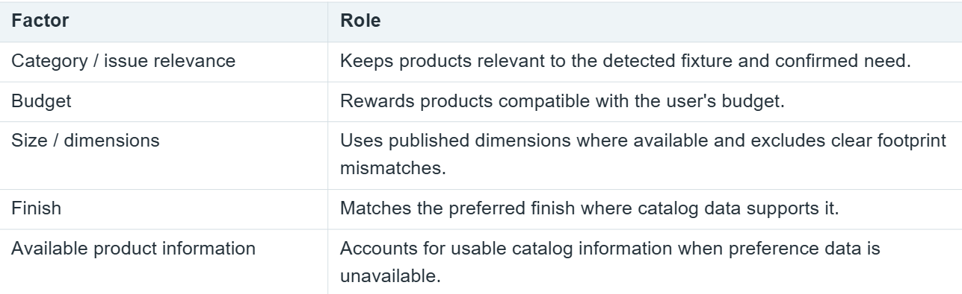
The implementation ranks relevant products using weighted scoring and returns the highest-scoring candidates subjected to its filters. Catalog records include SKU, product name, category/subcategory, price, dimensions, installation type, finish, material where available, and source page
INPUTS

Detected Fixture
+ Confirmed Issue
+ Room Dimensions
+ Budget
+ Finish Preference
↓
KOHLER Product Catalog
↓
Category Filtering
↓
Budget Filtering
↓
Dimension Compatibility
↓
Finish Matching
↓
Weighted Scoring
↓
Top Recommendations

Configuration workflow
Confirmed Fixture
↓
Determine Relevant Product Categories
↓
Retrieve Candidate Products
↓
Check Budget
↓
Check Available Dimensions
↓
Calculate Configuration Score
↓
Generate Product Combination

2D Visualization workflow
The 2D layout is generated by application code, not by the AI model. It uses user-provided room dimensions and available product-dimension data to scale product footprints within an indicative floor plan.

Error Handling and future scope
- Image quality can prevent reliable fixtures or issue detection
- Visible symptoms do not gurantee the exact underlying mechanical cause
- AI detection is presented for user confirmation
- Recommendations depend of the available catalog information
- Missing dimensions may require professional dimensional verification
- The 2D visuaization is indicative
- Price book prices and specifications may change over time

